**ONLINE SALES DASHBOARDS**:

Brand Contribution in Total Sales:

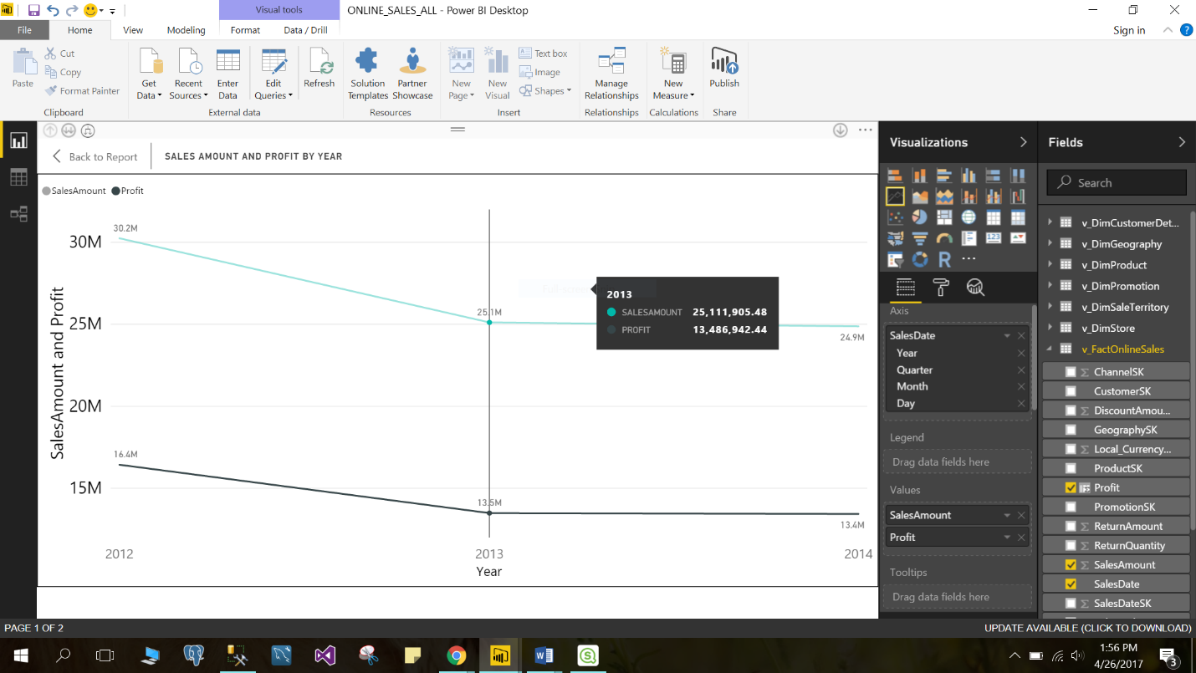

Brand Contribution In Total Sales

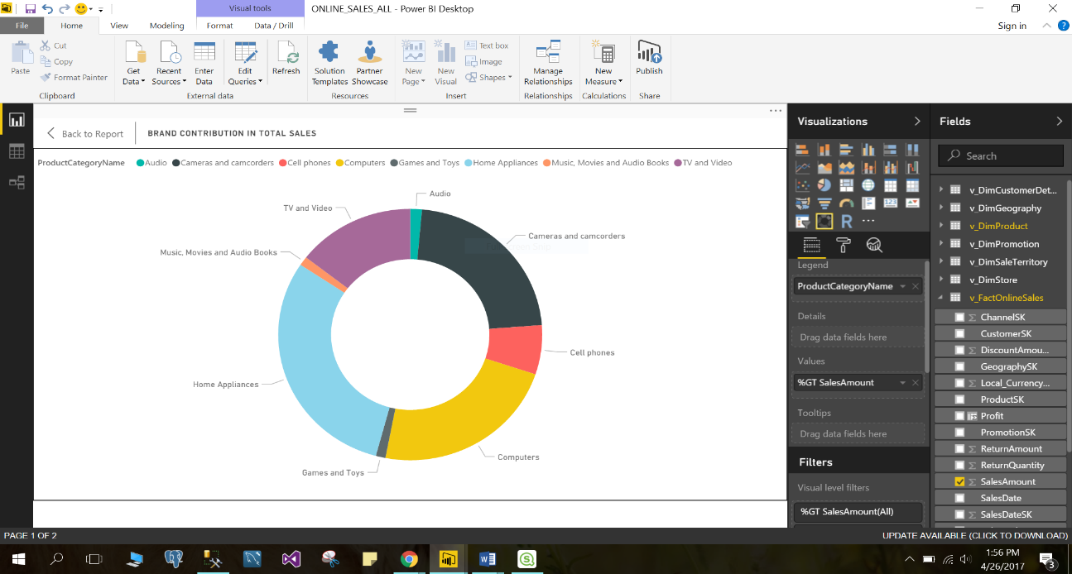

Sales Amount by Year:

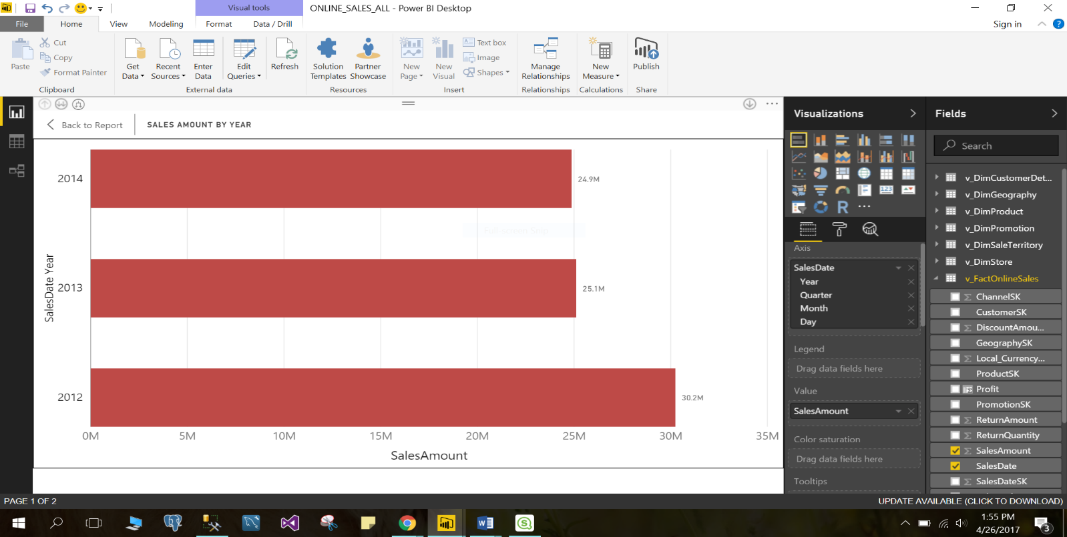

Customer number for every brand by year

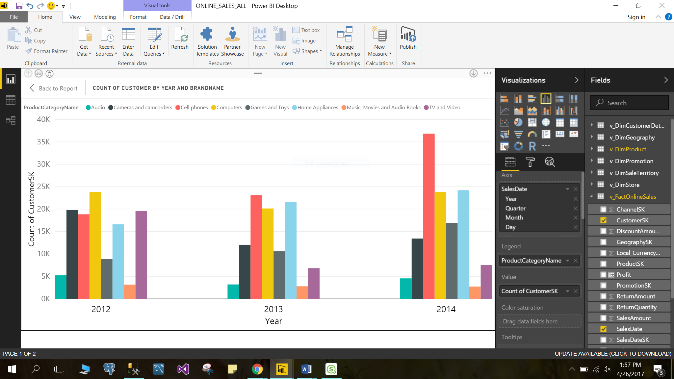

**STORE SALES**

Top 5 contributing Departments in the total sales

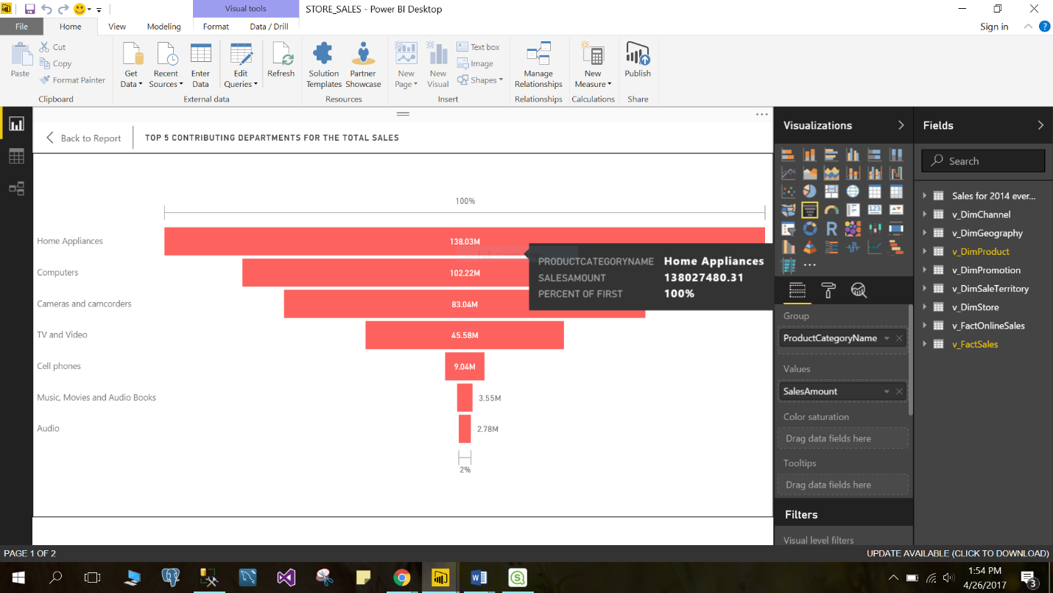

Total Sales by Month and Brand for 2014

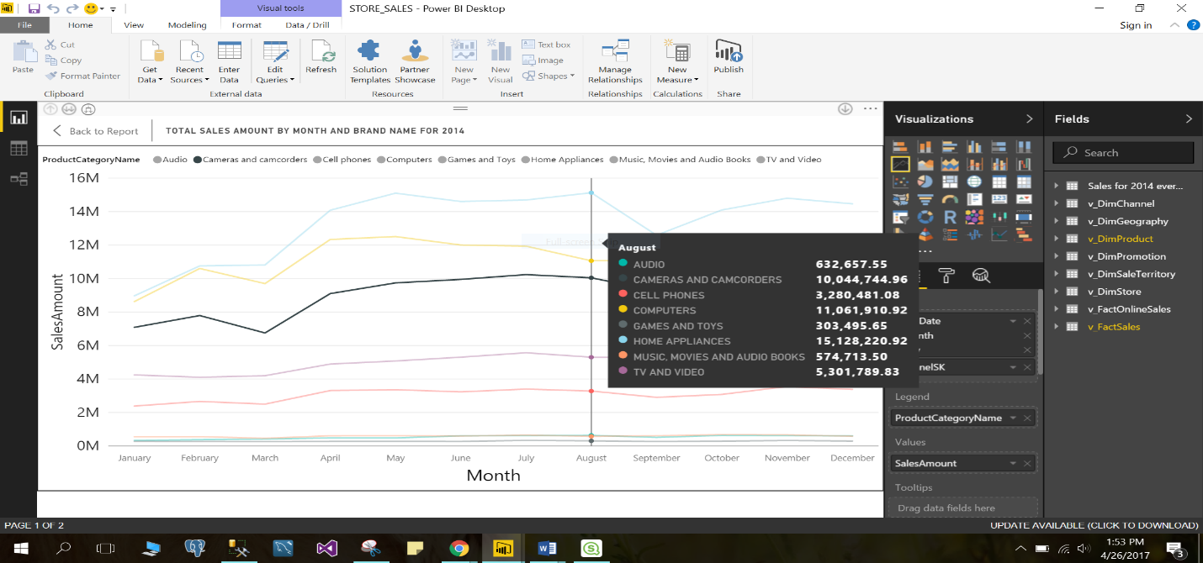

Top 5 Brands by Product Margin

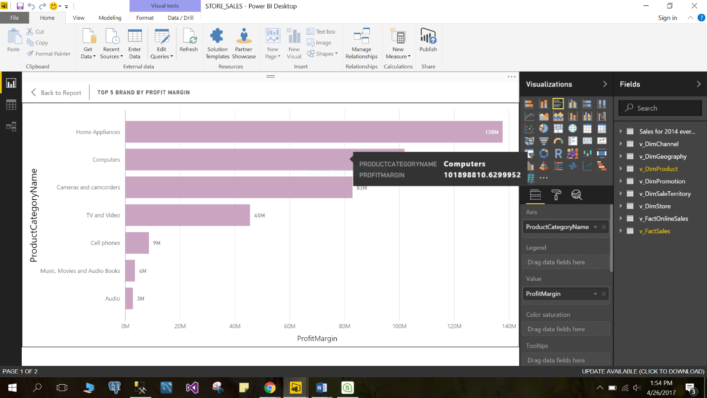

Average Quantity of Products Bought By Product and by Product Categoty

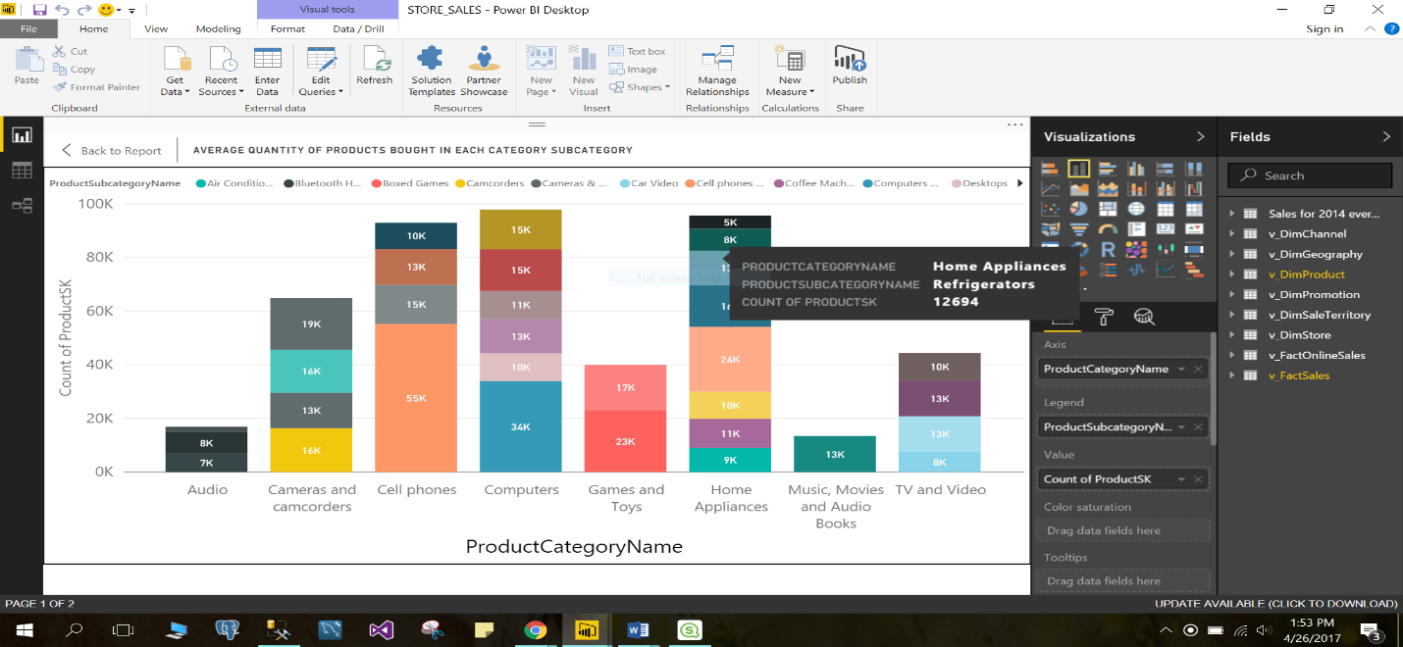

**SALES QUOTA**

**Budget Forecast and Plan Amount By Product Category**

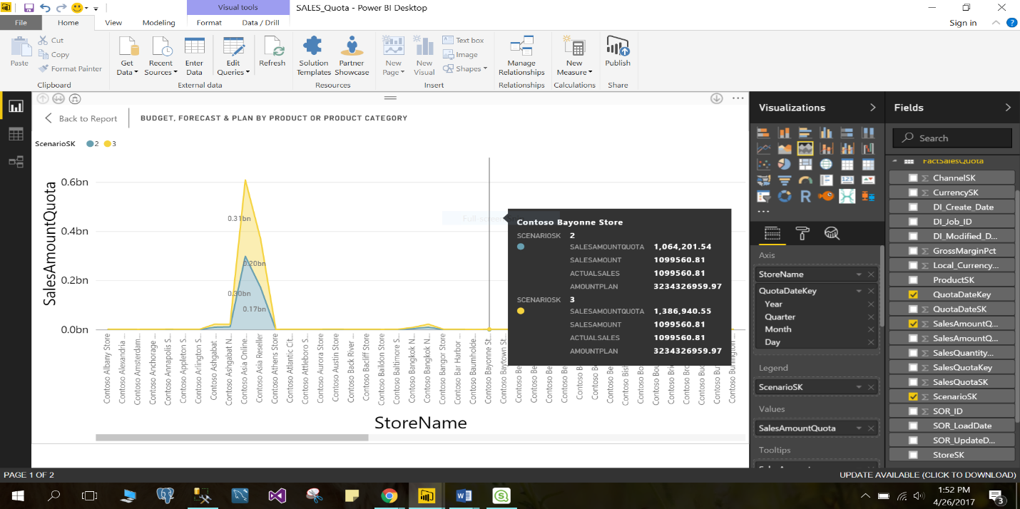

**Budget Forecast and Plan Amount By Product in 2014 in MA**

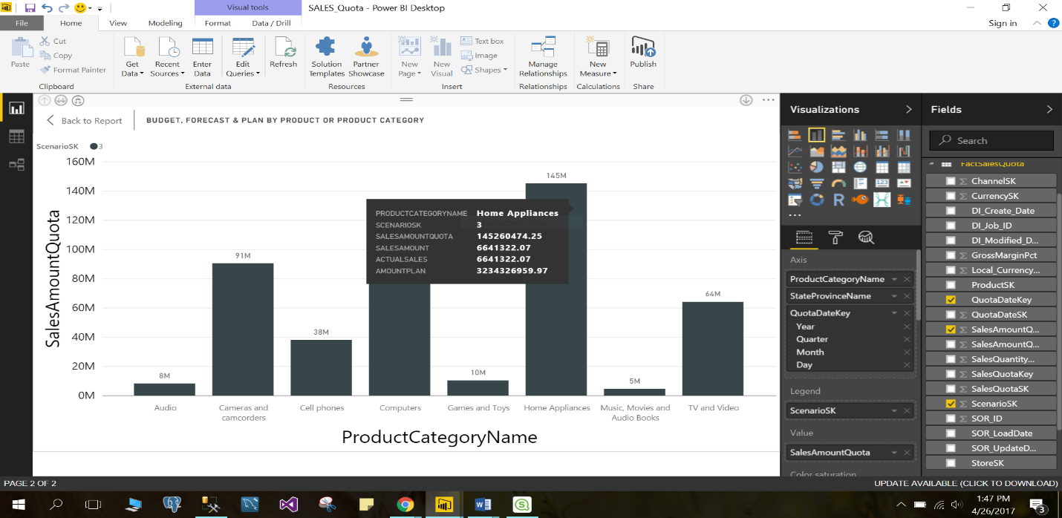

**Budget Forecast and Plan Amount by Country product category**

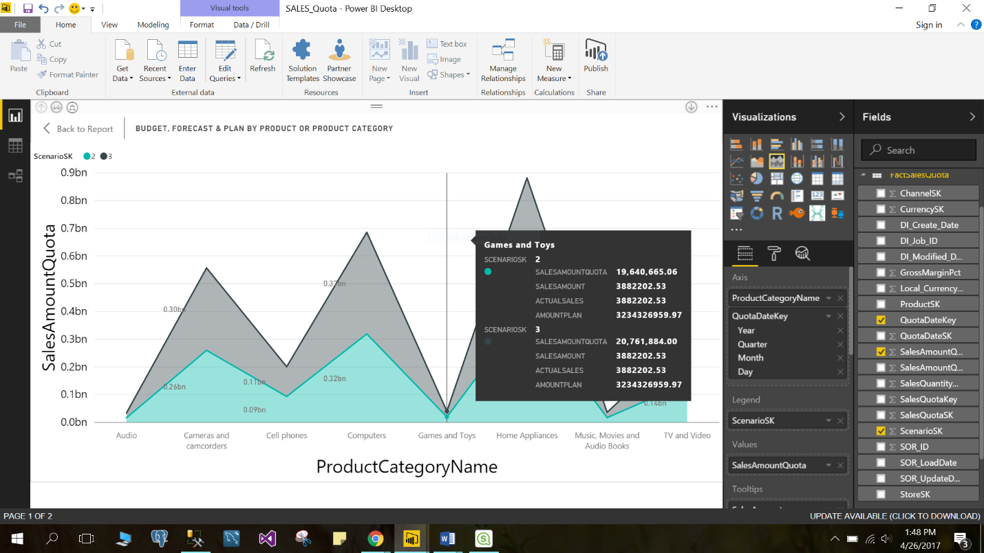

**Budget Forecast and Plan Amount By Country Product and Category**

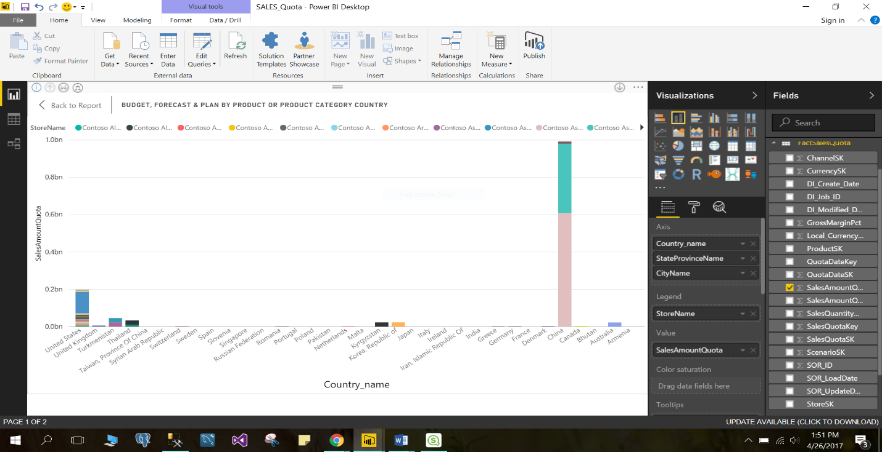

**Sales Amount Quota by year and Product Category**

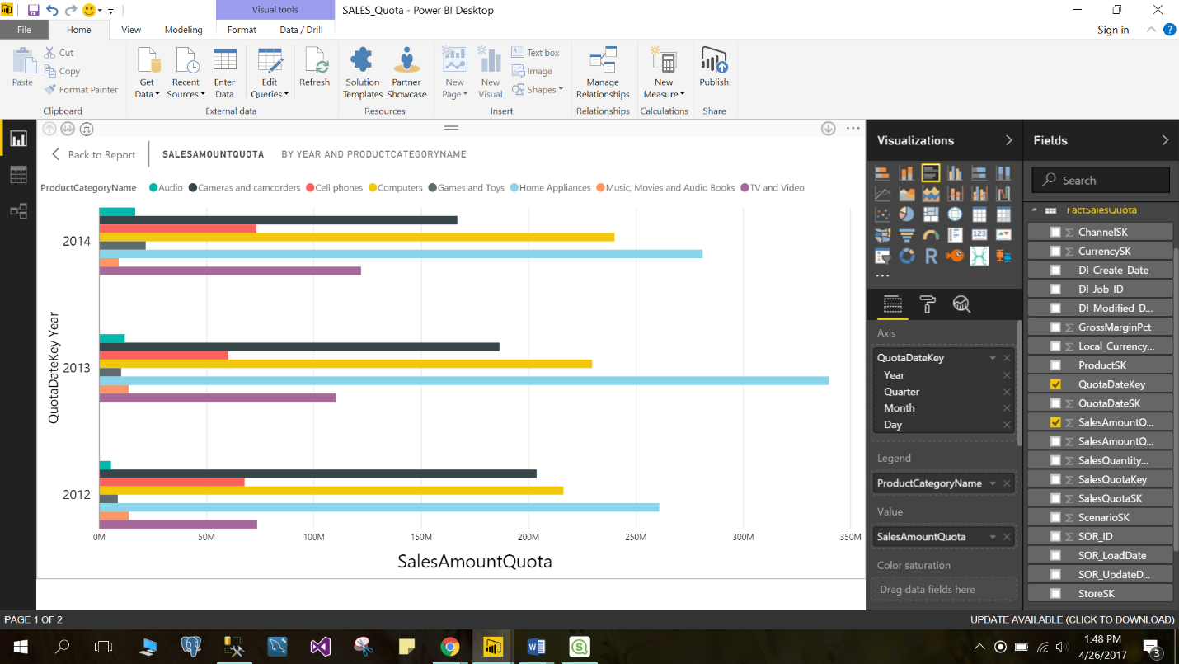

**INVENTORY SALES**

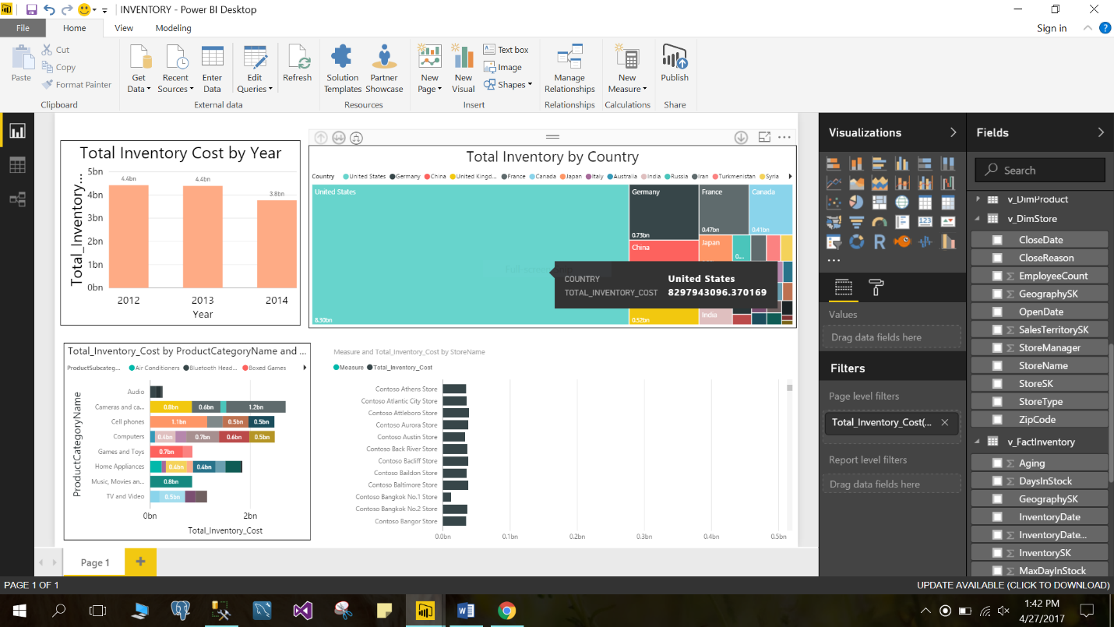

**Difference between tools**

